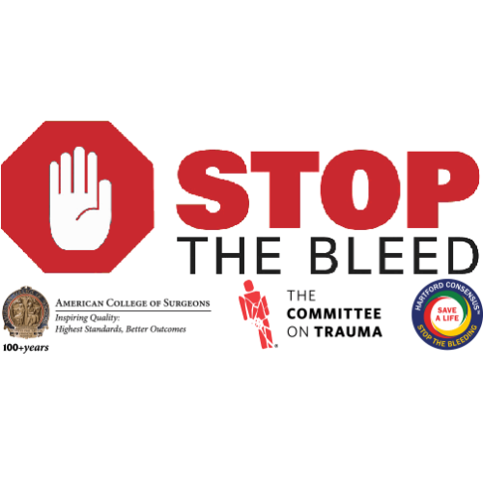

As part of the national Stop the Bleed campaign, **Penn State Health** **Holy Spirit Trauma Services** presents a **FREE** community outreach program for the general public on how to manage life threatening bleeding until Emergency Medical Services (EMS) or first responders arrive.

This course follows the program that was developed by the American College of Surgeons Committee on Trauma and the Hartford Consensus group. The program is approximately 1.5 hours in length and teaches the basic principles of bleeding control and tourniquet use until trained emergency providers arrive. The program is a combination of lecture, video, demonstration, and hands on skill stations using direct pressure, gauze packing, dressings, and tourniquets.

This course is designed for anyone and everyone, Teachers, Day Care workers, Firefighters, Law Enforcement Officers, Students, Food Service workers, and the general public.

**No prior first aid training is needed to take the class**

For information on how to attend a class or have a class brought to your organization, contact:

Sunny Goodyear, MSN, RN, CCRN

Trauma Outreach Injury Prevention Coordinator

Penn State Health Holy Spirit Medical Center

717-975-3267

[sgoodyear@pennstatehealth.psu.edu](mailto:daerdman@geisinger.edu)

***No matter how rapid the arrival of professional emergency responders, bystanders will always be first on the scene. A person who is bleeding can die from blood loss within five minutes, so it’s important to quickly stop the blood loss.***

***Remember to be aware of your surroundings and move yourself and the injured person to safety, if necessary.***

***Call 911***

***Bystanders can take simple steps to keep the injured alive until appropriate medical care is available. Here are three actions you can take to help save a life:***

